Anothing Weather App

DESIGN DOCUMENT

By Robin Jünemann

Introduction 2

App Summary Pitch 2

Inspiration 2

User Experience 3

Platform 3

Development Tools 3

Target Audience 3

Concept 3

Feature overview 3

Art 4

Theme Interpretation 4

Design 4

Development Timeline 5

## Introduction

### App Summary Pitch

Anothing Weather App is a minimalistic and clean looking weather web app. It features a weather lookup function with city name and postal codes and a weather forecast.

### Inspiration

**Google Weather App**

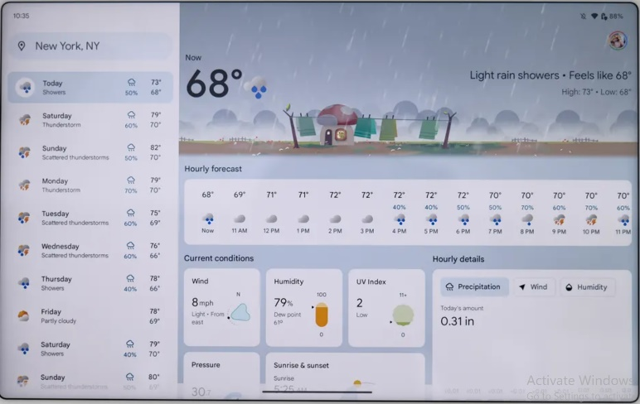The Google Weather app shows a lot of information in one screen without being overwhelming. It features a detailed hourly view for the currently selected day and a 10-day forecast. Its utilities a big screen rly well so even so it is a good starting point for an app that is viewable on the web and as an app.

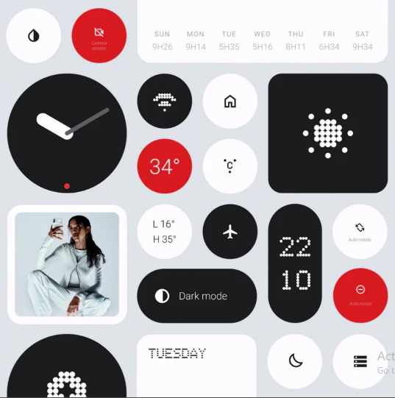**Nothing UI**

The Nothing UI is my main visual inspiration. The mainly black and white aesthetic with one contrast color. I want to recreate the pixilated illustrations as well. The app should look simple and pleasing but without making compromises in features and readability.

### User Experience

The app should provide all important information at a first glance. This is achieved through the high contrast and big numbers and symbols. A minimalistic and stylized UI is the goal. It should be pleasing to look at and use. The goal is to create a UX that is easy to use without giving much up in terms of information density.

### Platform

The app is developed for the Web and as an android/iOS app.

### Development Tools

* Angular for frontend
* Ionic for UI
* Accuweather API

Figma for Prototype

### Target Audience

The Target Audience are people who want a stylistically pleasing user interface with all the important information. One possible usage would be the usage of a tablet as a permanent information display.

## Concept

### Feature overview

The display should show the following information: Location, current temperature, weather forecast for the current day, weather forecast for the week, wind speed and direction, humidity and maybe the risk of rain.

## Art

### Theme Interpretation

While maintaining the very limited color palette theme, the sole use of black in white seems way too common, and a bit harsh as a color scheme for a weather app. To circumvent this, a soft, red color will act as the unique accent color as opposed to black with white being the sole, carrying color to base the graphics off.

### Design

A very **minimalistic** approach will go into the design of the game, heavily relying on the severe contrast of the limited colors to provide detail. Though, the design still is clean and smooth in the sense that, the use of many shades of a color will not be as present to confront the **retro style** and pixel art.

## Development Timeline

**MINIMUM VIABLE PRODUCT**

| **#** | **Assignment** | **Type** | **Status** | **Finish By** | **Notes** |
| --- | --- | --- | --- | --- | --- |
| 1 | Design Document | Other | Finished | Dec 4, 2023 |  |
| 2 | Create Figma Prototype | Art | Finished | Dec 6, 2023 | This should test the overall layout |
| 3 | Choose Weather Icons | Art | Finished | Dec 10, 2023 |  |
| 4 | Create Angular Project | Coding | Finished | Dec 11, 2023 |  |
| 5 | Implement Ionic Framework | Coding | Finished | Dec 12, 2023 |  |
| 6 | Learn how to use the accuweather api | Coding | Finished | Dec 15, 2023 |  |
| 7 | Searching for location | Coding | Finished | Dec 19, 2023 |  |
| 8 | Displaying associated weather data for that location | Coding | Finished | Dec 22, 2023 |  |
| 9 | Create the main UI | Coding | Finished | Dec 31, 2023 |  |
| 10 | Implement all the dynamic data | Coding | Not started | Jan 5, 2023 |  |

**BEYOND (if ahead of schedule / extra time)**

|  |  |  |  |
| --- | --- | --- | --- |
| Figma Mobile Layout | Art | Not started |  |
| Create Layout in Angular | Coding | Not started |  |
| Dynamic Switch between layouts | Coding | Not started |  |